RECIPE | SUGAR FREE CHEWING GUM WITH SWEETENERS. WITH CBD
Global appearance of product | Chewing gum with white coating, rectangular shape, soft in the core
Flavour | Blackcurrant flavour
Tipology of product | Sugar FREE chewing gum with sweeteners
Shape | Rectagle shape, Weight 1.44 g +/- 0.05 g
INGREDIENTS | Sweeteners: sorbitol, isomalt, maltitol syrup, acesulfame K, sucralose; gum base, flavourings, acidity regulator: citric acid; CBD isolate (0.58%), hemp seed oil (0.72%), humectant: glycerol; thickener: arabic gum; rice starch, glazing agent: carnauba wax; antioxidant: E306.
% INGREDIENTS | 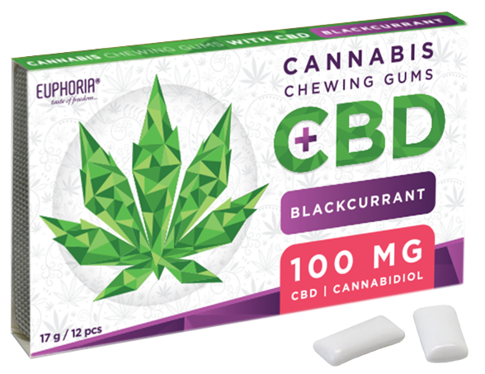
  Name | %
  Sorbitol | 39,17
  Isomalt | 28,00
  Gum base | 21,00
  Maltitol syrup | 4,90
  Flavours | 2,30
  Citric acid | 1,05
  Hemp seed oil | 0,72
  Arabic gum | 0,70
  Glycerol | 0,70
  Rice starch | 0,60
  CBD | 0,58
  Acesulfame k | 0,11
  Sucralose | 0,11
  Carnauba wax | 0,05
  Antioxidant | 0,01
  Total | 100
Nutrition informations
  PER 100g |  | Per 1 chewing gum 1,44 g
  ENERGY | 766 KJ (184 kcal) | 11 KJ (3 Kcal)
  FAT | 0,7 g | 0 g
  Of which saturated fats acids | 0 g | 0 g
  CARBOIDRATES | 72 g | 1 g
  Of wich polyols | 72 g | 1 g
  Of wich sugar | 0 g | 0 g
  FIBRE | 0.7 g | 0.01 g
  PROTEIN | 0 g | 0 g
  SALT | 0 g | 0 g
  CBD | 578,7 mg | 8,33 mg
Packaging | 1 pack 17 g of gums with 12 gums
Transport and storage conditions | Store cool and dry. Keep away from the humidity and heatfonts. (12-30°C- 50/60% r.h.)
Shelf life | 3 years under storage conditions described above
GMO | GMO free
Allergens | May contain traces of SOY
Consumers | Celiac disease  Yes | Seniors  Yes |  | Children  No |  | Vegans  Yes |  | Diabetics  Yes
Warnings | Excessive consumption may produce laxative effect.
Microbiological features (ufc/g) | TMC  <3000 |  | Total Coliforms  Absent |  | Salmonella  Absent |  | Staphylococcus aureus  Absent |  | Moulds and yeasts  <100

